**WEB TECHNOLOGIES**

ASSIGNMENT-1

**TRAVEL GUIDE** using HTML, CSS and JAVASCRIPT

**Done By:**

K. Rishika

1602-20-737-097

G. Ramya

1602-20-737-095

Features

1. HTML
2. <html> tag
3. <body> tag
4. <head> tag
5. <img> tag
6. <link> tag
7. <a> tag
8. <header> tag
9. <main> tag
10. <footer> tag
11. <nav> tag
12. <div> tag
13. <section> tag
14. <span> tag
15. <p> tag
16. <script> tag
17. <li> tag
18. CSS
19. Class selectors
20. Id selectors
21. Element selectors
22. Background-image
23. Background-color
24. Margin
25. Border
26. Flex
27. Font-family
28. Font-size
29. Text-align
30. Text-decoration
31. Padding
32. Border-radius
33. Opacity
34. Width
35. Height
36. JavaScript
37. Functions
38. variables
39. Form Validation
40. Alert messages
41. Focus
42. Document value fetch

**Code**

1. HTML

a)home.html

<html>

<head>

<title>Travel Guide</title>

<link href="home.css" rel="stylesheet">

</head>

<body class="body">

<nav class="navbar background">

<ul class="nav-list">

<div class="logo">

<img src="C:\Users\Dell\OneDrive\Desktop\WT\travel.png">

</div>

<li><a href="home.html">Home</a></li>

</ul>

</nav>

<div class="national">

<p class="p1" style="font-size:100px; font-family: 'Times New Roman', Times, serif;" align="center">

<a href="national.html" >National</a>

</p>

</div>

<div class="international">

<p class="p1" style="font-size:100px; font-family: 'Times New Roman', Times, serif;" align="center">

<a href="international.html" >International</a>

</p>

</div>

</body>

</html>

b)national.html

<html>

<head>

<title>Travel Guide</title>

<link href="home.css" rel="stylesheet">

</head>

<body class="body">

<nav class="navbar background">

<ul class="nav-list">

<div class="logo">

<img src="C:\Users\Dell\OneDrive\Desktop\WT\travel.png">

</div>

<li><a href="home.html">Home</a></li>

</ul>

</nav>

<div class="national">

<p class="p1" style="font-size:100px; font-family: 'Times New Roman', Times, serif;" align="center">

<a href="national.html" >National</a>

</p>

</div>

<div class="international">

<p class="p1" style="font-size:100px; font-family: 'Times New Roman', Times, serif;" align="center">

<a href="international.html" >International</a>

</p>

</div>

</body>

</html>

c)international.html

<html>

<head>

<title>Travel Guide</title>

<link href="places.css" rel="stylesheet">

</head>

<body class="body">

<nav class="navbar background">

<ul class="nav-list">

<div class="logo">

<img src="C:\Users\Dell\OneDrive\Desktop\WT\travel.png">

</div>

<li><a href="home.html">Home</a></li>

</ul>

</nav>

<div>

<p>

<h1 align="center">Select your budget</h1>

<budget class="budget">

<select class="select" name="select" onchange="location = this.value;">

<option>-</option>

<option value="budget1.html">75,000-1,00,000</option>

<option value="budget2.html">1,00,000-2,00,000</option>

</select>

</budget>

</p>

</div>

</body>

</html>

d) budget1.html

<html>

<head>

<title>Travel Guide</title>

<link href="places.css" rel="stylesheet">

</head>

<body class="body">

<nav class="navbar background">

<ul class="nav-list">

<div class="logo">

<img src="C:\Users\Dell\OneDrive\Desktop\WT\travel.png">

</div>

<li><a href="home.html">Home</a></li>

</ul>

</nav>

<div class="container">

<div class="image">

<img src="C:\Users\Dell\OneDrive\Desktop\WT\Vietnam.png" height="150px" width="250px">

</div>

<div class="text">

<p><h2>Vietnam</h2></p>

<p><h3>Best time to visit:</h3> March-April</p>

<p><h3>Places to visit:</h3> 1. Halong Bay · 2. Ho Chi Minh City · 3. Hue · 4. Phong Nha-Ke Bang National Park · 5. My Son · 6. Hoi An</p>

</div>

</div>

<div class="container">

<div class="image">

<img src="C:\Users\Dell\OneDrive\Desktop\WT\Thailand.png" height="150px" width="250px">

</div>

<div class="text">

<p><h2>Thailand</h2></p>

<p><h3>Best time to visit:</h3> November-April</p>

<p><h3>Places to visit:</h3> 1. Wat Phra Chetuphon · 2. BTS Skytrain · 3. Chatuchak Weekend Market · 4. The Grand Palace · 5. Temple Of Dawn (Wat Arun)</p>

</div>

</div>

<div class="container">

<div class="image">

<img src="C:\Users\Dell\OneDrive\Desktop\WT\UAE.png" height="150px" width="250px">

</div>

<div class="text">

<p><h2>UAE</h2></p>

<p><h3>Best time to visit:</h3> November-March</p>

<p><h3>Places to visit:</h3> 1. The Dubai Fountain · 2. Sheikh Zayed Grand Mosque Center · 3. Burj Khalifa · 4. Ferrari World · 5. Atlantis Aquaventure</p>

</div>

</div>

</body></html>

e) budget2.html

<html>

<head>

<title>Travel Guide</title>

<link href="places.css" rel="stylesheet">

</head>

<body class="body">

<nav class="navbar background">

<ul class="nav-list">

<div class="logo">

<img src="C:\Users\Dell\OneDrive\Desktop\WT\travel.png">

</div>

<li><a href="home.html">Home</a></li>

</ul>

</nav>

<div class="container">

<div class="image">

<img src="C:\Users\Dell\OneDrive\Desktop\WT\japan.png" height="150px" width="250px">

</div>

<div class="text">

<p><h2>Japan</h2></p>

<p><h3>Best time to visit:</h3> March-May and September-November</p>

<p><h3>Places to visit:</h3> 1. Tokyo · 2. Kyoto · 3. Naoshima · 4. Mt Fuji · 5. Hiroshima · 6. Yakushima · 7. Koya-san </p>

</div>

</div>

<div class="container">

<div class="image">

<img src="C:\Users\Dell\OneDrive\Desktop\WT\norway.png" height="150px" width="250px">

</div>

<div class="text">

<p><h2>Norway</h2></p>

<p><h3>Best time to visit:</h3> June-August</p>

<p><h3>Places to visit:</h3> 1. Mount Floyen and the Funicular · 2. Fram Museum · 3. Vigeland Park · 4. Bryggen Hanseatic Wharf · 5. Geiranger Fjord</p>

</div>

</div>

<div class="container">

<div class="image">

<img src="C:\Users\Dell\OneDrive\Desktop\WT\turkey.png" height="150px" width="250px">

</div>

<div class="text">

<p><h2>Turkey</h2></p>

<p><h3>Best time to visit:</h3> April-May and September-October</p>

<p><h3>Places to visit:</h3> 1. Hagia Sophia (Aya Sofya) Mosque · 2. Ephesus · 3. Cappadocia · 4. Topkapi Palace · 5. Pamukkale · 6. Antalya · 7. Cruising the Mediterranean </p>

</div>

</div>

</body></html>

f) budget3.html

<html>

<head>

<title>Travel Guide</title>

<link href="places.css" rel="stylesheet">

</head>

<body class="body">

<nav class="navbar background">

<ul class="nav-list">

<div class="logo">

<img src="C:\Users\Dell\OneDrive\Desktop\WT\travel.png">

</div>

<li><a href="home.html">Home</a></li>

</ul>

</nav>

<div class="container">

<div class="image">

<img src="C:\Users\Dell\OneDrive\Desktop\WT\shimla.png" height="150px" width="250px">

</div>

<div class="text">

<p><h2>Shimla, Himachal Pradesh</h2></p>

<p><h3>Best time to visit:</h3>May-June and December-January</p>

<p><h3>Places to visit:</h3> 1. Jakhu Temple · 2. The Mall · 3. Viceregal Lodge · 4. The Ridge · 5. Indian Institute of Advanced Study · 6. Annandale Ground</p>

</div>

</div>

<div class="container">

<div class="image">

<img src="C:\Users\Dell\OneDrive\Desktop\WT\Alleppey.png" height="150px" width="250px">

</div>

<div class="text">

<p><h2>Alleppey, Kerala </h2></p>

<p><h3>Best time to visit:</h3> November-February</p>

<p><h3>Places to visit:</h3> 1. Marari Beach · 2. Pathiramanal · 3. Backwaters of Kuttanad · 4. Krishnapuram Palace · 5. Alleppey Beach · 6. Arthunkal Church.</p>

</div>

</div>

<div class="container">

<div class="image">

<img src="C:\Users\Dell\OneDrive\Desktop\WT\rishikesh.png" height="150px" width="250px">

</div>

<div class="text">

<p><h2>Rishikesh, Uttarakhand</h2></p>

<p><h3>Best time to visit:</h3>October-February</p>

<p><h3>Places to visit:</h3> 1. Triveni Ghat · 2. Kunjapuri Devi Temple · 3. Vashishta Gufa · 4. Neer Garh Waterfall · 5. Ram Jhula · 6. Parmarth Niketan Ashram </p>

</div>

</div>

</body></html>

g) budget4.html

<html>

<head>

<title>Travel Guide</title>

<link href="places.css" rel="stylesheet">

</head>

<body class="body">

<nav class="navbar background">

<ul class="nav-list">

<div class="logo">

<img src="C:\Users\Dell\OneDrive\Desktop\WT\travel.png">

</div>

<li><a href="home.html">Home</a></li>

</ul>

</nav>

<div class="container">

<div class="image">

<img src="C:\Users\Dell\OneDrive\Desktop\WT\udaipur.png" height="150px" width="250px">

</div>

<div class="text">

<p><h2>Udaipur, Rajasthan</h2></p>

<p><h3>Best time to visit:</h3>September-March</p>

<p><h3>Places to visit:</h3> 1. City Palace of Udaipur · 2. Lake Pichola · 3. Bagore Ki Haveli Museum · 4. Shri Ekling Ji Temple · 5. Jagdish Temple</p>

</div>

</div>

<div class="container">

<div class="image">

<img src="C:\Users\Dell\OneDrive\Desktop\WT\gulmarg.png" height="150px" width="250px">

</div>

<div class="text">

<p><h2>Gulmarg, Jammu & Kashmir</h2></p>

<p><h3>Best time to visit:</h3> March-May and September-December</p>

<p><h3>Places to visit:</h3>1. Gulmarg Gondola · 2. Apharwat Peak · 3. Outer Circle Walk · 4. Ningle Nallah · 5. Alpather Lake · 6. Rani Temple · 7. Kongdori</p>

</div>

</div>

<div class="container">

<div class="image">

<img src="C:\Users\Dell\OneDrive\Desktop\WT\mumbai.png" height="150px" width="250px">

</div>

<div class="text">

<p><h2>Mumbai, Maharashtra</h2></p>

<p><h3>Best time to visit:</h3>October-February</p>

<p><h3>Places to visit:</h3> 1. Gateway of India · 2. Marine Drive · 3. Bandra-Worli Sea Link · 4. Shree Siddhivinayak · 5. Chhatrapati Shivaji Terminus · 6. KidZania Mumbai </p>

</div>

</div>

</body></html>

**2) CSS**

a)home.css

* {

margin: 0;

padding: 0;

}

.navbar {

display: flex;

align-items: center;

justify-content: center;

position: sticky;

top: 0;

cursor: pointer;

}

.background {

background: #0a0a0a;

background-blend-mode: darken;

background-size: cover;

}

.nav-list {

width: 95%;

display: flex;

align-items: center;

}

.logo img {

width: 150px;

border-radius: 5px;

}

.nav-list li {

list-style: none;

padding: 26px 30px;

}

.nav-list li a {

text-decoration: none;

color: white;

}

.nav-list li a:hover {

color: grey;

}

.national

{

background-color: rgba(4, 4, 4, 0.75);

padding: 120px;

border-bottom:black;

}

.international

{

background-color: rgba(6, 6, 6, 0.75);

padding: 110px;

}

a:link {

color:white;

}

body {

background-image: url(https://www.popsci.com/uploads/2023/02/24/AirportPlane.png?auto=webp);

background-size: cover;

background-repeat: no-repeat;

color: #FFFFFF;

}

div{

border: 5px solid #000000;

}

b)places.css

* {

margin: 0;

padding: 0;

}

.navbar {

display: flex;

align-items: center;

justify-content: center;

position: sticky;

top: 0;

cursor: pointer;

}

.background {

background: #0a0a0a;

background-blend-mode: darken;

background-size: cover;

}

.nav-list {

width: 95%;

display: flex;

align-items: center;

}

.logo img {

width: 150px;

border-radius: 5px;

}

.nav-list li {

list-style: none;

padding: 26px 30px;

}

.nav-list li a {

text-decoration: none;

color: white;

}

.nav-list li a:hover {

color: grey;

}

.budget

{

padding: 610px;

margin-top: 100px;

width: 50px;

}

.select

{

height:50px;

width: 300px;

font-size: x-large;

font-family: 'Times New Roman', Times, serif;

}

.container {

display: flex;

align-items: left;

justify-content: left;

padding:50px;

}

.image {

flex-basis: 20%;

}

.text {

font-size: 20px;

padding-left: 5px;

}

SCREENSHOTS

1. Home page

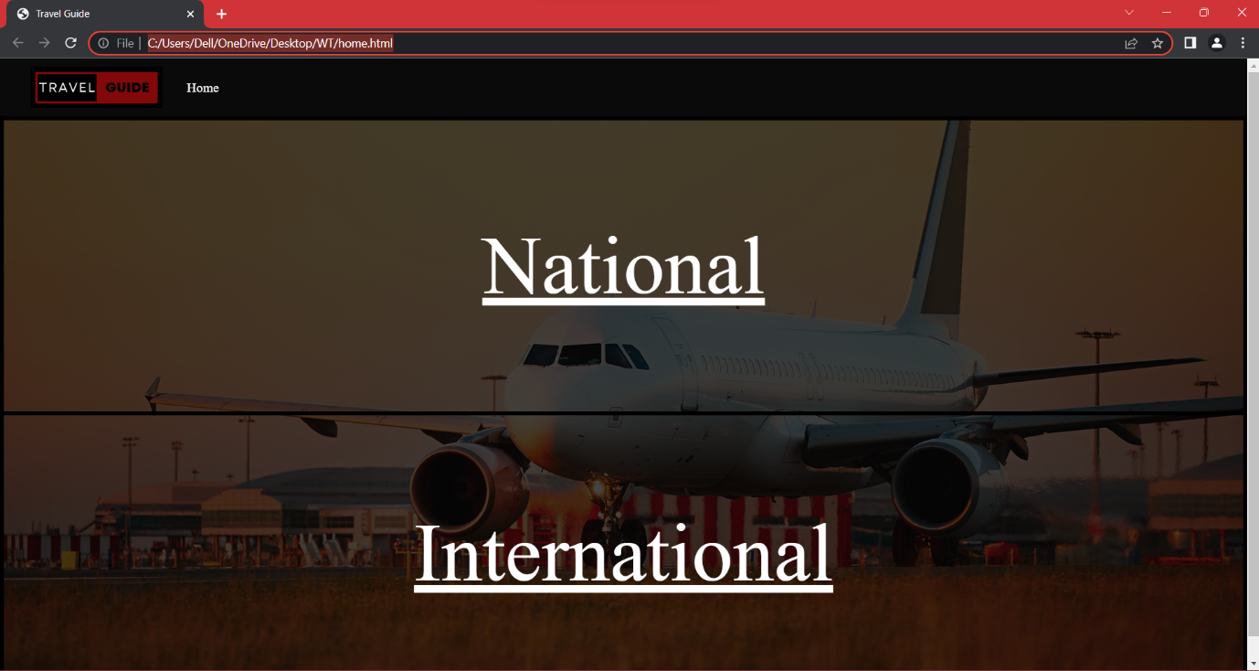

1. National budget

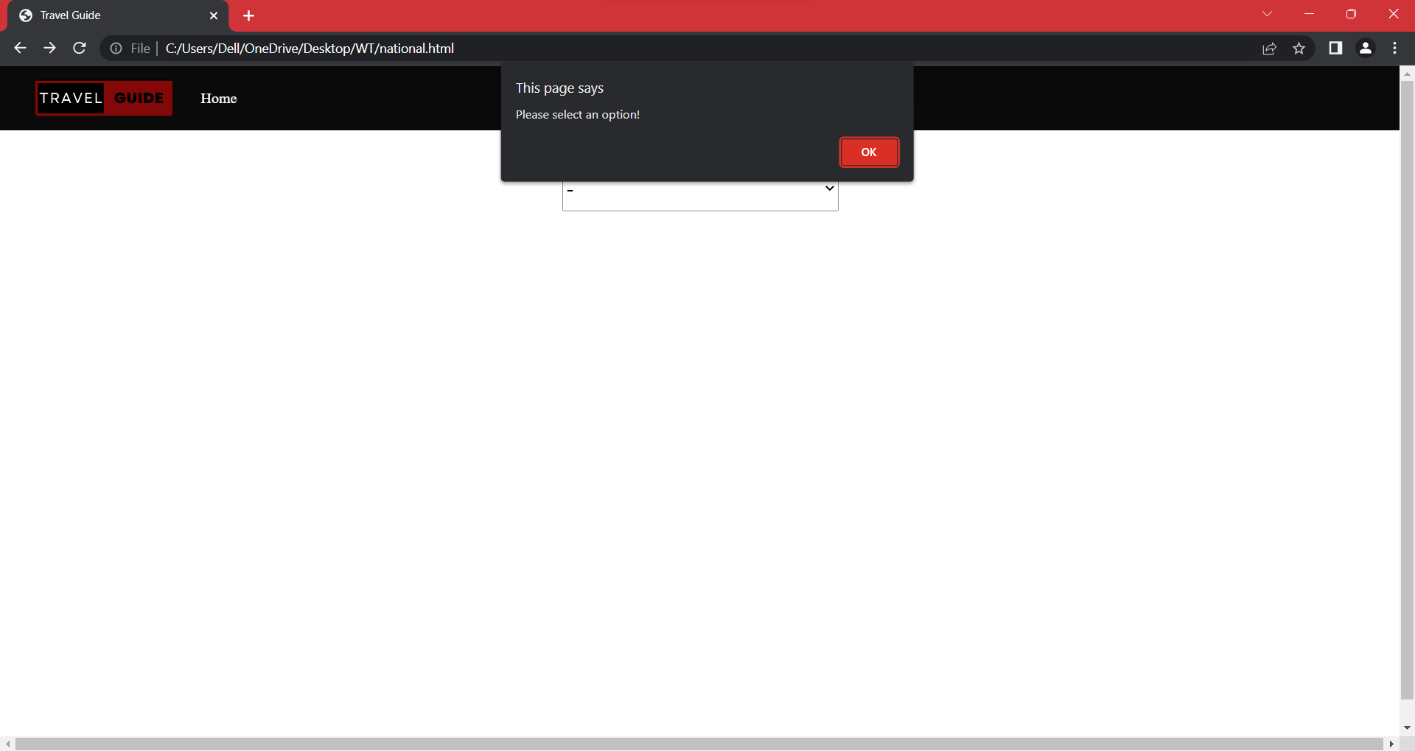

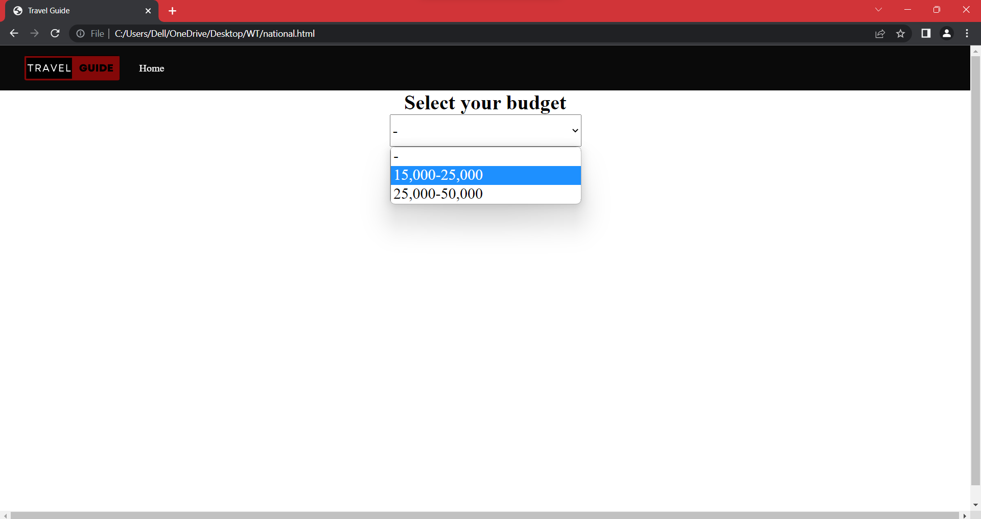

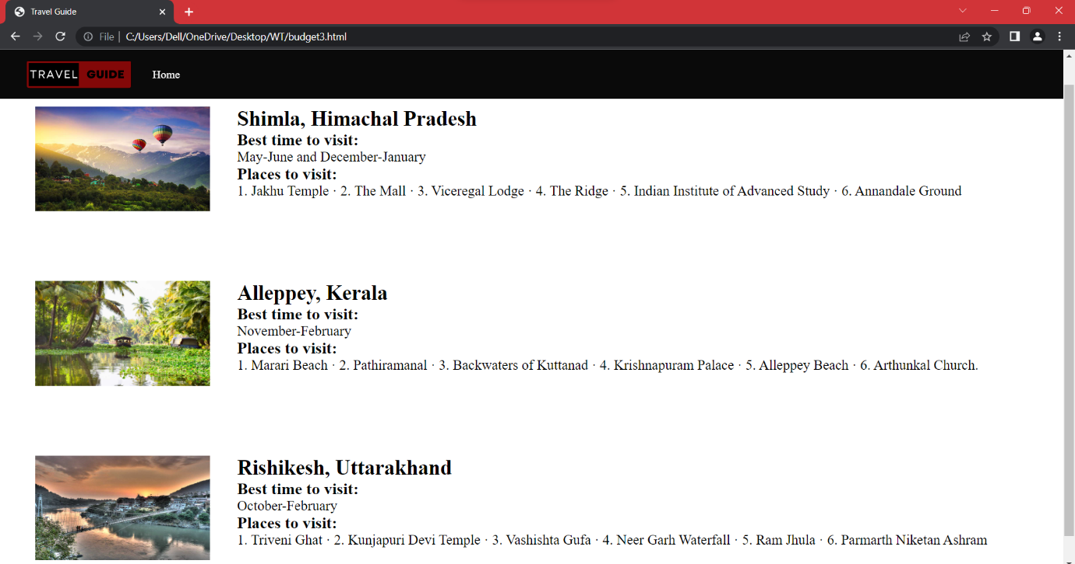

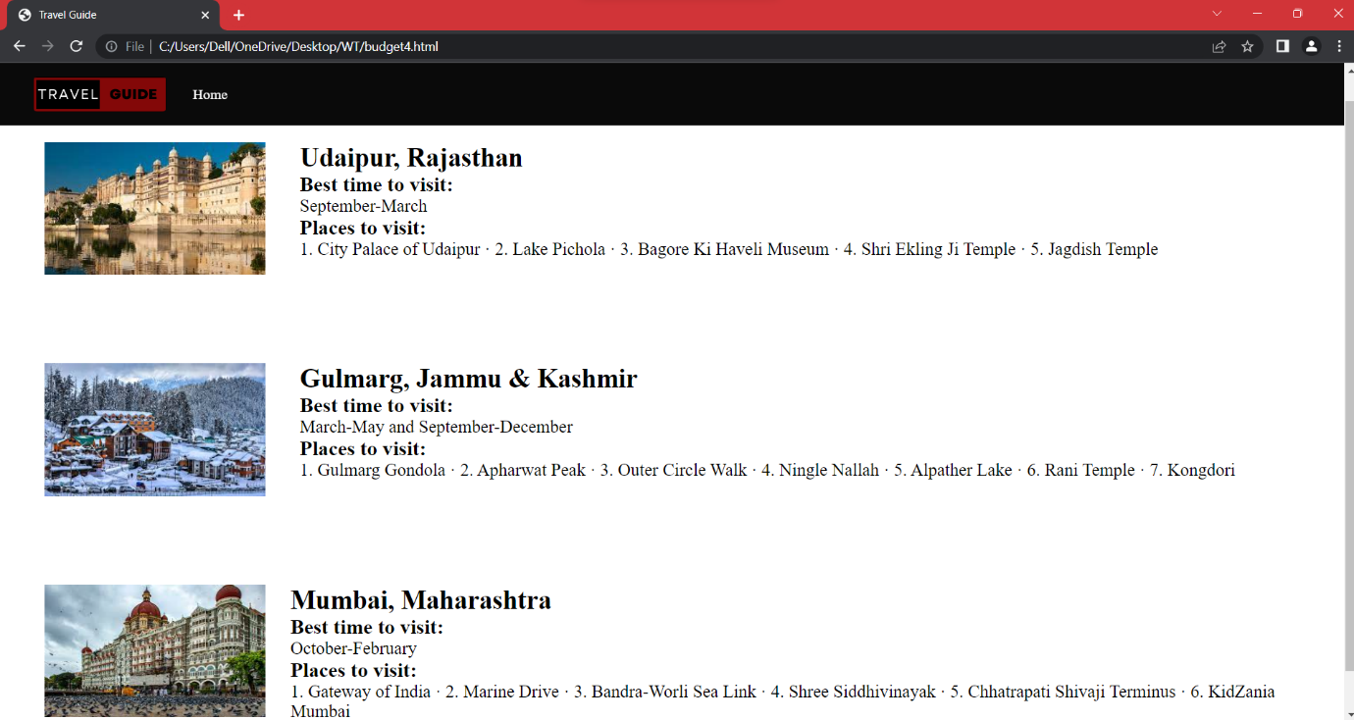

1. International budget

